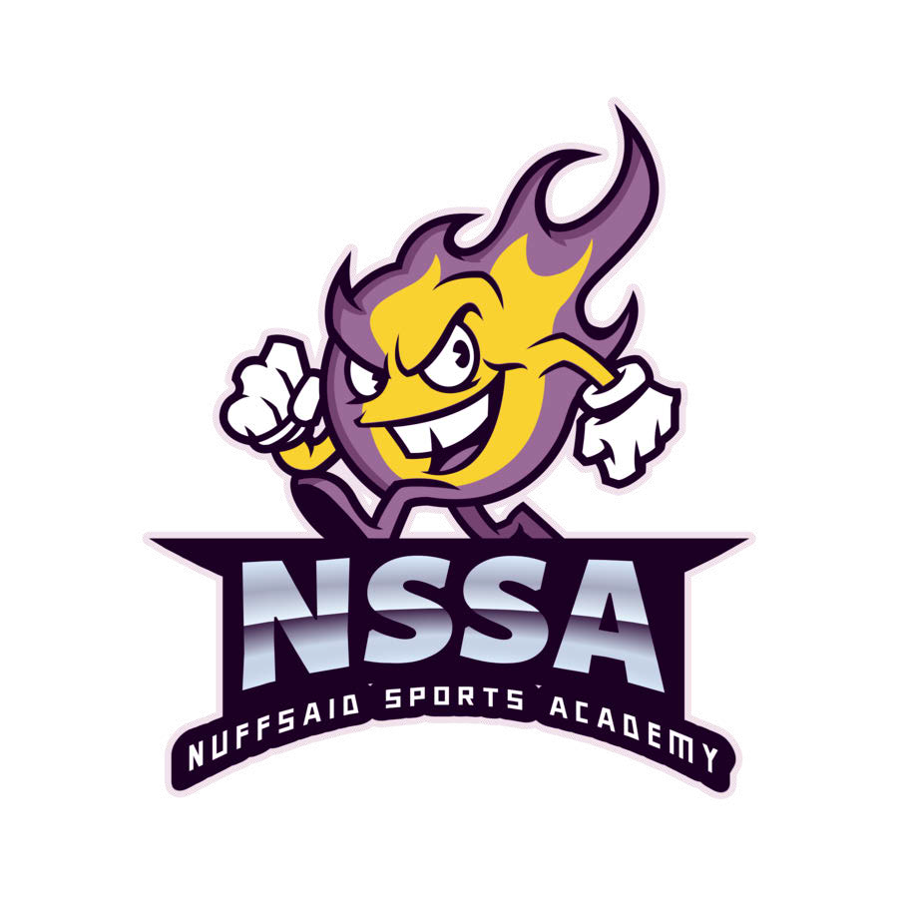

2025 NuffSaid Sports Academy Sponsorship Form
Sponsor Information:

Sponsor Name:
Address including street, city, state, and zip
Business Phone:
Business E-mail:
Business Website:
Contact Name and Title:
Contact Phone:
Contact Email:
If interested in sponsoring a specific player’s team, please provide player’s information below:

Player Name:
Age:
League/Division:

Sponsorship Levels & Pricing Please check one:
Purple Yellow
Brickhouse
1YR Banner 1YR Team
1YR Team
________

________

________
$500

$400

$300
What is included in each level
Purple:
Yellow: Brickhouse:
Company name on team shirt, logo patch on sleeve, website advertisement, banner Company name on team shirt, website advertisement
Company name on team shirt

Logo Information
PAYMENT OPTIONS
Our banner and team sponsors require the sponsorship logo for marketing materials including listings on our website. Logos will also be added to the sleeve of the players jersey of the team being sponsored. Logos in .jpg and .png formats can be emailed to nssa1@yahoo.com

Sponsor name
In the blocks below, please provide us with the exact text of the sponsor name to be added to the back of player jerseys. Please print in capital letters.
Maximum number of characters per line is 18, which includes spaces. Longer text will drop to Line 2.

 | 1 | 2 | 3 | 4 | 5 | 6 | 7 | 8 | 9 | 10 | 11 | 12 | 13 | 14 | 15 | 16 | 17 | 18
Line #1
Line #2

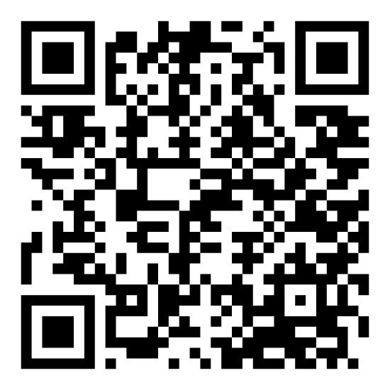

When on the site's homepage, click on the pay tab on top of page, select credit card, and follow the instructions
For credit card payments Scan the QR code

Check Instructions
Payment should be payable to Gustavo Duanys (NSSA) and mailed to: Nuffsaid Sports Academy
21 Ellsworth St
Worcester, MA 01610

